Manual Test Plan 1.2

1. Test for Information displaying
2. Test for Check
3. Test for Checkmate
4. Test for Undo
5. Test for Forfeit
6. Test for No one lost, restart
7. Test for user scores

1.1

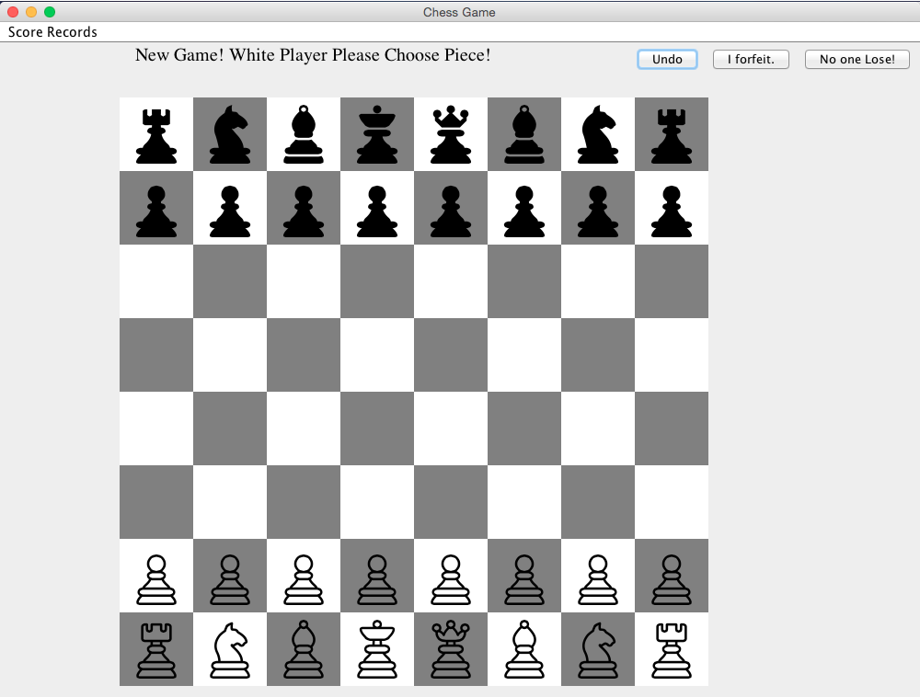

In the beginning, the text show above is “New Game...” which is correct.

1.2

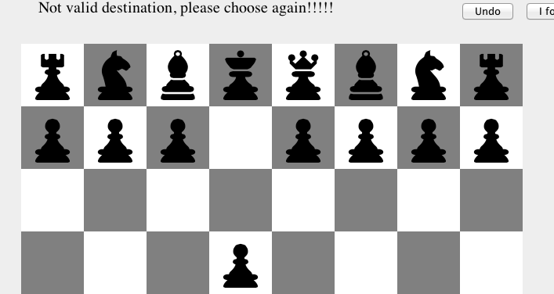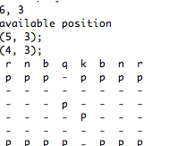

When I choose a wrong destination the display would show. In the controller, it will show the available position black piece can move to. And then the piece also moved.

1.3

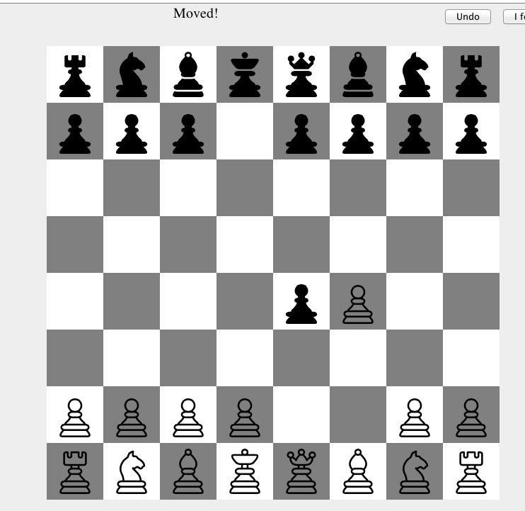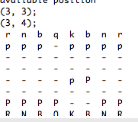

Black is able to eat my white piece.

2. Check

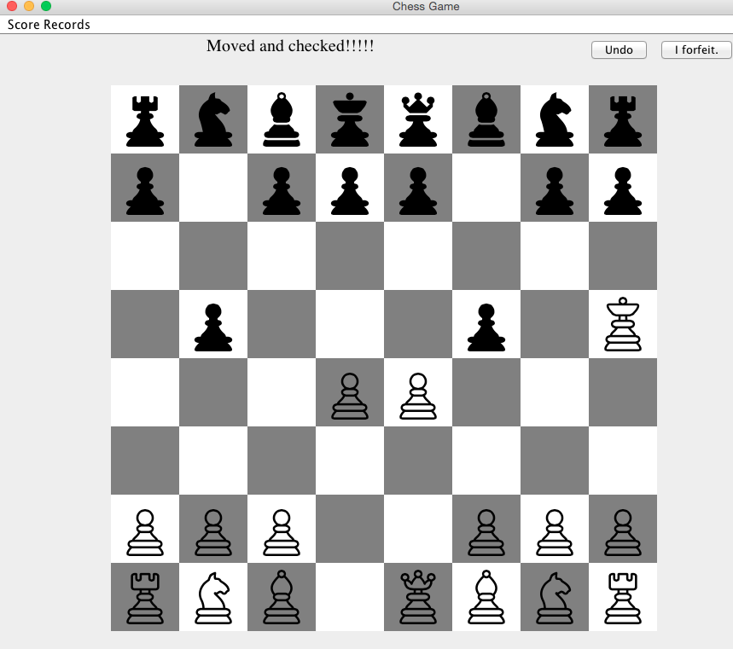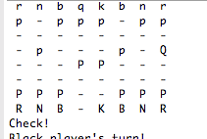

We can display check as shown above. (both GUI and logic board)

3. Checkmate

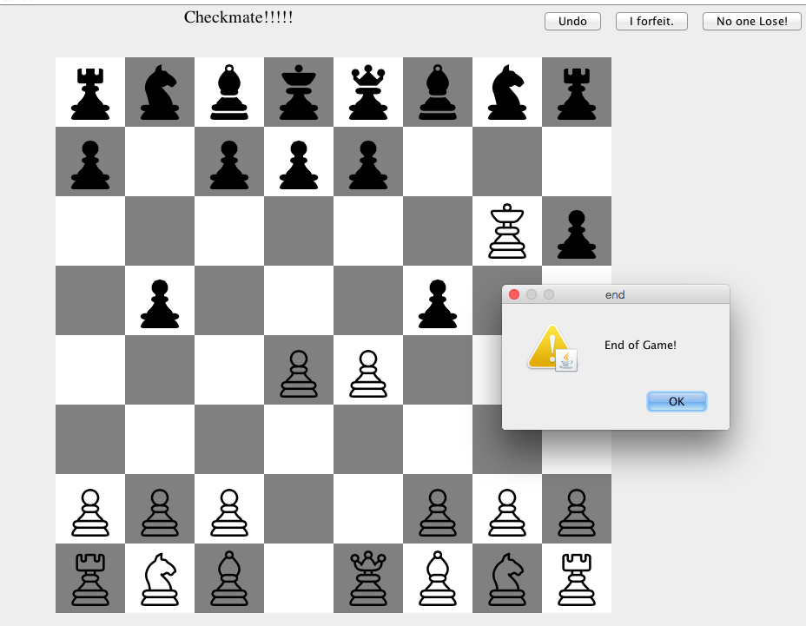

So we get to checkmate at this step. And the game ends, we will have the pop up window.